Project Development Phase
Model Performance Test

Date | 17 February 2026
Team ID | LVIP2026TMIDSB7385
Project Name | AI Travel Itinerary Generator using Streamlit & Gemini API
Maximum Marks | 10 Marks

Model Performance Testing:
S.No. | Parameter | Values | Screenshot
 | Metrics | Generative AI Model (Gemini Flash API)  Evaluation Method:  - Prompt-based output testing  - Multiple destination test cases executed  - Output checked for:  • Relevance to destination  • Correct day-wise structure  • Interest-based customization  • Response completeness  Observed Result:  Model generated structured and context-aware itineraries successfully for different inputs. | 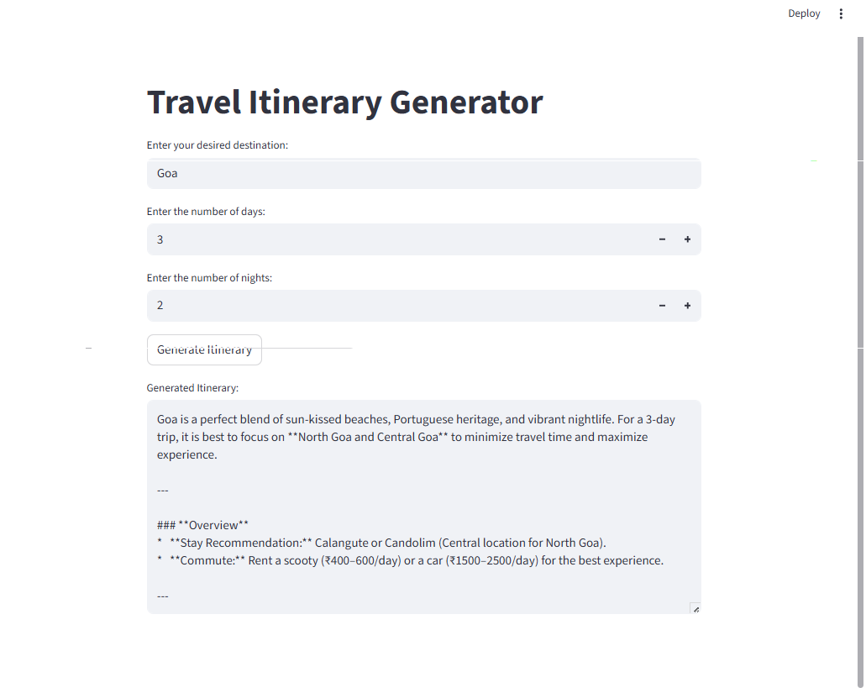
 | Tune the Model | No fine-tuning performed.  Used pretrained Gemini model via API.  Performance improved using prompt engineering:  - Structured prompts  - Clear constraints (days, nights, interests)  - Format instructions for itinerary output | 